Bubble Chart in R, A bubble chart is majorly used to show the relationships between numeric variables and it can visualize two to four dimensions.

The first two dimensions for coordinates, the third dimension is for color and the fourth as size.

Bubble chart is an enhancement of the normal scatter plot instead of traditional dots or points in the scatter plot are replaced by circles or bubbles.

In this article will describe how to create bubble chart based on ggplot2 and plotly.

**Bubble Chart in R**

First, load ggplot2 package in R

**Method 1:-**

In ggplot2 allows to render almost all type of charts and graphs. In this article approach is like load the library, create a data frame and display plot.

library(ggplot2)

Load the data from mtcars

data("mtcars")

df <- mtcars

Let’s convert cyl as a grouping variable

df$cyl <- as.factor(df$cyl)

Let’s see the data frame

head(df[, c("wt", "disp", "cyl", "qsec")])

  wt disp cyl  qsec

Mazda RX4         2.620  160   6 16.46

Mazda RX4 Wag     2.875  160   6 17.02

Datsun 710        2.320  108   4 18.61

Hornet 4 Drive    3.215  258   6 19.44

Hornet Sportabout 3.440  360   8 17.02

Valiant           3.460  225   6 20.22

Points size is controlled by a continuous variable, in this case qsec. argument alpha is used to control color transparency and should lies between 0 and 1.

ggplot(df, aes(x = wt, y = disp)) +

  geom_point(aes(color = cyl, size = qsec), alpha = 0.5) +

  scale_color_manual(values = c("#AA4371", "#E7B800", "#FC4E07")) +

  scale_size(range = c(1, 13)) + # Adjust the range of points size

  theme_set(theme_bw() +theme(legend.position = "bottom"))

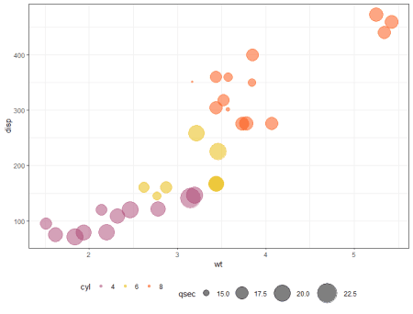

**Method 2:-**

library(plotly)

bubbleplot <- plot_ly(df, x = ~wt, y = ~disp,

                      text = ~cyl, size = ~qsec,

                      color = ~cyl, sizes = c(10, 50),

                      marker =

                        list(opacity = 0.7,

                             sizemode = "diameter"))

bubbleplot <- bubbleplot%>%layout

bubbleplot

